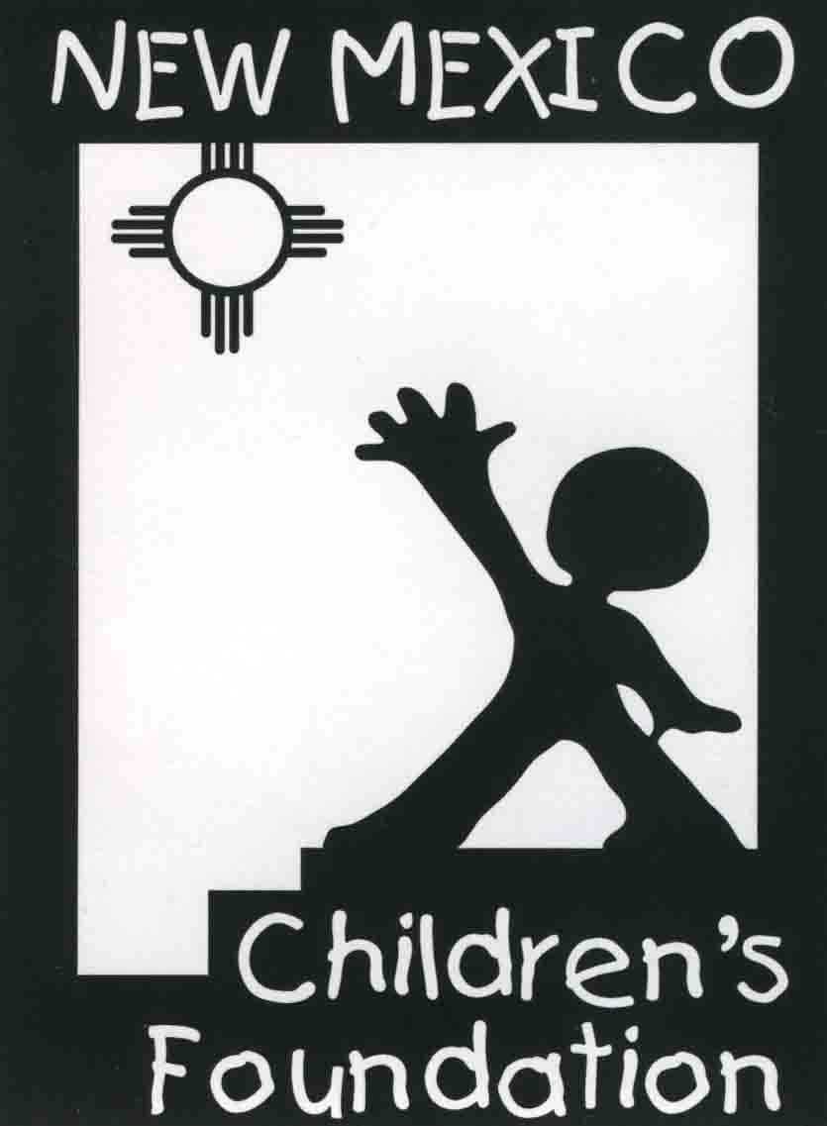
Grants Funded for 2020-2021

- Assistance League of Chaves County, Roswell
- Bookkids, Santa Fe
- Bridges for Education Project, Taos
- Camp Enchantment New Mexico
- Cancer Services of New Mexico, Santa Fe
- CASA First Judicial District, Santa Fe, Rio Arriba & Los Alamos Counties
- Common Bond, Albuquerque
- Compassionate Touch Network, Albuquerque, Rio Rancho & Santa Fe
- Elevate
- El Pueblo de Abiquiu Library
- El Rito Public Libary
- Embudo Valley Library & Community Center, Dixon
- Embudo Valley Tutoring, Dixon
- Friends of the Espanola Library
- Young Fathers New Mexico
- Gila Valley Library, Northwestern Grant County
- Growing Great Kids, Raton
- High Mountain Youth Project, Ruidoso
- Imagination Library of Luna County
- Kirkland Youth Association, Kirkland
- Literacy Links Leamos, Silver City
- Locker #505 Students Clothing Bank
- Many Mothers, Santa Fe
- New Mexico Lions Kids Sight
- Northern Youth Project, Abiquiu
- Ojo Sarco Community Center, Ojo Sarco
- Santa Fe Alliance for Science
- STEM Santa Fe, Santa Fe & Northern New Mexico
- Truchas Services Center, Truchas
- Valencia County Literacy Council, Los Lunas
- Villa Therese Catholic Clinic, Santa Fe
- Wings for Life Roswell, Roswell

